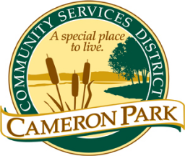
Cameron Park Community Services District
2502 Country Club Drive
Cameron Park, CA 95682

Architectural Review Committee
Tuesday, April 12, 2022
8:30 a.m.

Cameron Park Community Services District
2502 Country Club Drive, Cameron Park

Agenda

Members: Chair, Kathi Markan (KM), Vice-Chair, Brennen Overstreet (BO), Jeff Heuerman (JH)
Alternates: Kathryn Gilfillan (KG), David Chighizola (DC)
Staff: CC&R Compliance Officer Jim Mog

Cancelled

