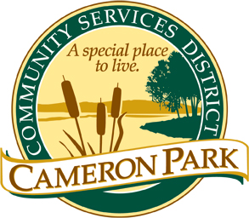
CAMERON PARK COMMUNITY SERVICES DISTRICT
2502 Country Club Drive
Cameron Park, CA 95682
(530) 677-2231 Phone
(530) 677-2201 Fax
www.cameronpark.org
AGENDA

Regular Board of Directors Meetings are held
Third Wednesday of the Month

SPECIAL BOARD MEETING
Wednesday, September 13, 2023
6:30 p.m.

Cameron Park Community Center
Social Room
2502 Country Club Drive, Cameron Park

The Board will convene into Closed Session shortly after the adoption of the Agenda.

Board Members
Sidney Bazett  Monique Scobey  Eric Aiston  Tim Israel  Dawn Wolfson | President  Vice President  Board Member  Board Member  Board Member

CALL TO ORDER
- Roll Call
- Pledge of Allegiance

Public testimony will be received on each agenda item as it is called. Principal party on each side of an issue is allocated 10 minutes to speak, individual comments are limited to 3 minutes except with the consent of the Board; individuals shall be allowed to speak on an item only once. Members of the audience are asked to volunteer their name before addressing the Board. The Board reserves the right to waive said rules by a majority vote.

ADOPTION OF THE AGENDA
The Board will make any necessary additions, deletions, or corrections to the Agenda and motion to adopt the Agenda.

- Adopt the Agenda

OPEN FORUM FOR NON-AGENDA ITEMS
Members of the public may speak on any item not on the agenda that falls within the jurisdiction of the Board of Directors.

PUBLIC COMMENT
At this time, members of the public may speak on any closed session agenda item. Closed sessions may be called as necessary for personnel, litigation, and labor relations or to meet the negotiator prior to the purchase, sale, exchange, or lease of real property. Members of the public may address the Board prior to closing the meeting.

CONVENE TO CLOSED SESSION
The Board will recess to closed session to discuss the following item(s):
- Pubic Employment Pursuant to Government Code section 54957 – General Manager Recruitment

RECONVENE TO OPEN SESSION AND REPORT OUT OF CLOSED SESSION
Pursuant to Government Code §54957.1, the legislative body of any local agency shall publicly report any action taken in closed session and the vote or abstention of every member present thereon.

ADJOURNMENT

Please contact the District office at (530) 677-2231 or admin@cameronpark.org if you require public documents in alternate formats or accommodation during public meetings. For the public’s information, we are taking email requests at admin@cameronpark.org for future notification of
Cameron Park Community Services District meetings.

