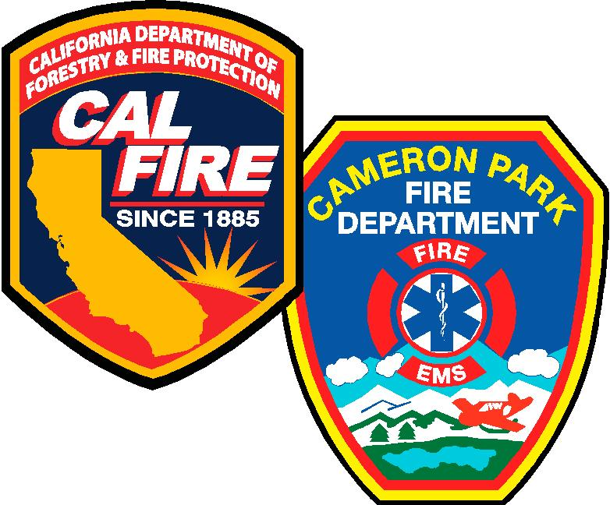
CAMERON PARK FIRE DEPARTMENT
Currently accepting applications for INTERN FIREFIGHTER
Department Information:
- 2 ALS engine companies and 1 ALS transporting ambulance
- 2 Stations, approximately 4500 calls per year

Resident Firefighter duties:
- 24 hour shifts assigned to an engine company
- Participate in trainings and daily duties
- $80 per shift reimbursement stipend

Minimum Qualifications:
- California State Firefighter I certification or completion of accredited Fire Academy
- EMT- AED certification
- Current CPR certification
- Current California Driver License
- Free from any felony convictions
- Successful completion of medical exam (paid for by department)
- Successful completion of a DOJ background check (paid for by department)
Application available online @ www.cameronpark.org
Accepting applications in person @ Fire Station 89, 3200 Country Club Drive Cameron Park, CA 95682

