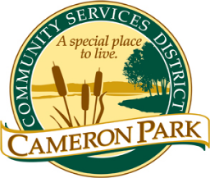
Cameron Park Community Services District
2502 Country Club Drive
Cameron Park, CA 95682

Architectural Review Committee
Meeting
Tuesday, November 29th, 2022
8:30 a.m.

Cameron Park Community Center – Social Room
2502 Country Club Drive, Cameron Park

CANCELED

Members: Chair, Kathi Markan (KM), Vice-Chair, Brennen Overstreet (BO), Jeff Heuerman (JH)
Alternate: Kathryn Gilfillan (KG)
Staff: CC&R Compliance Officer Jim Mog
CALL TO ORDER

ROLL CALL

Public testimony will be received on each agenda item as it is called. Principal party on each side of an issue is allocated 10 minutes to speak, individual comments are limited to 3 minutes except with the consent of the Committee; individuals shall be allowed to speak on an item only once. Members of the audience are asked to volunteer their name before addressing the Committee. The Committee reserves the right to waive said rules by a majority vote.

APPROVAL OF AGENDA

APPROVAL OF CONFORMED AGENDA

- Conformed Agenda – ARC Committee Meeting –
OPEN FORUM
Members of the public may speak on any item not on the agenda that falls within the responsibilities of the Committee.

COMMITTEE REVIEW/ACTION

Items Requiring ACTION - Discuss and Approve

- New Business

Item # | Property Address | Unit | APN | Project

ADMINISTRATIVE APPROVALS

- Review and Support Staffs Approvals

- Staff Approved Roofs – ()

- Staff Approved Solar - ()

- Staff Approved Trees Removals - ()

- Review and Discuss

- Draft – Cameron Park Fence Guidelines

- Items for Future Architectural Review Committee Agendas

6. Items to take to the CC&R Committee

MATTERS TO AND FROM COMMITTEE MEMBERS AND STAFF
ADJOURNMENT

